|  |  |  |  |
| --- | --- | --- | --- |
| **Group No.** | **Group Members** | | |
|  | **ID** | **Name** |
| 3 | 1. | 20-42195-1 | LEO, NAFINUR |
| 2. | 20-42752-1 | HOWLADER, MD. SHAKIB |
| 3. | 20-42794-1 | FAHIM, SHAH NAWAJ |
| 4. | 20-42853-1 | RAHMAN, HASIBUR |
| 5. | 20-42870-1 | HASSAN, MD. ALIF |
|  |  |  |

**Laboratory Experiment Report**

Electronic Drives Laboratory

Semester: Spring 2021-22

|  |  |  |
| --- | --- | --- |
| Experiment No. : 02 |  | |
| Experiment Title : Study of Diode Rectifiers |  | |
| Date of Experiment: 30-01-2022 | | Date of Report Submission: 16-03-2022 |

**Marking Rubrics for Laboratory Report (to be filled by Faculty)**

|  |  |  |  |  |
| --- | --- | --- | --- | --- |
| **Objectives** | **Unsatisfactory (1)** | **Good (2-3)** | **Excellent (4-5)** | **Marks** |
| **Theory** | The relevant theories are not being described properly. | Part of the relevant theories are described with proper mathematical expression and circuit diagrams (if any) | All the relevant theories are included with proper descriptions, mathematical expressions and circuit diagrams. (if any) |  |
| **Simulation circuits & Results** | Simulation circuits are not included in this report. | Partial simulation circuit results are included in this report. | All the simulation circuits are included in this report with appropriate results. |  |
| **Report Question, Discussion on Comparison between theoretical and simulation results** | Cannot reach meaningful conclusions from experimental data; Cannot summarize or compare findings to expected results | Can extract most of the accurate data. Answers to the report questions are partially correct; Summarize finding in an incomplete way | Can extract all relevant conclusion with appropriate answer to the report questions; Summarize finding in a complete & specific way |  |
| **Organization of the report** | Report is not prepared as per the instruction. | Report is organized despite of few missing sections as per the recommended structure. | Report is very well organized. |  |
| **Comments** | Assessed by (Name, Sign, and Date) | | Total (out of 20): |  |

.

**(1) Experiment title: Study of Diode Rectifiers**

**(2) Objective of this experiment:**

The objectives of this lab are to:

1) study of Half wave rectifiers,

2) study of Full wave rectifiers.

**(3) Relevant Theory:**

Diode rectifiers are of the following types:

1. Half-wave rectifier.

2. Full-wave bridge rectifier.

3. Center tapped Full-wave rectifier.

A rectifier, however, cannot produce a smooth DC voltage. So, the rectification block that makes the output DC voltage a smooth one follows a filter circuit. In this case, the capacitor acts as a smoothing filter so that the output is nearly a dc voltage. A filtering is not perfect; there will be a remaining voltage fluctuation known as ripple, on the output voltage. The half-wave voltage signal is normally established by a network with a single diode has an average or equivalent DC voltage level equal to 31.8% of the peak voltage, whereas the full-wave rectified signal has twice the average or DC level of the half-wave signal, or 63.6% of the peak value.

**APPARATUS:**

No. Apparatus Quantity:

1 Diode 4

2 10k Resistance 1

3 Project Board 1

4 Oscilloscope 1

5 Multimeter 1

6 Transformer 220V/12V/9V/6V 1

7 47μF Capacitor 1

8 100μF Capacitor 1

9 Chord 2

**(4) Simulation circuits and Results:**

**Figure:1**

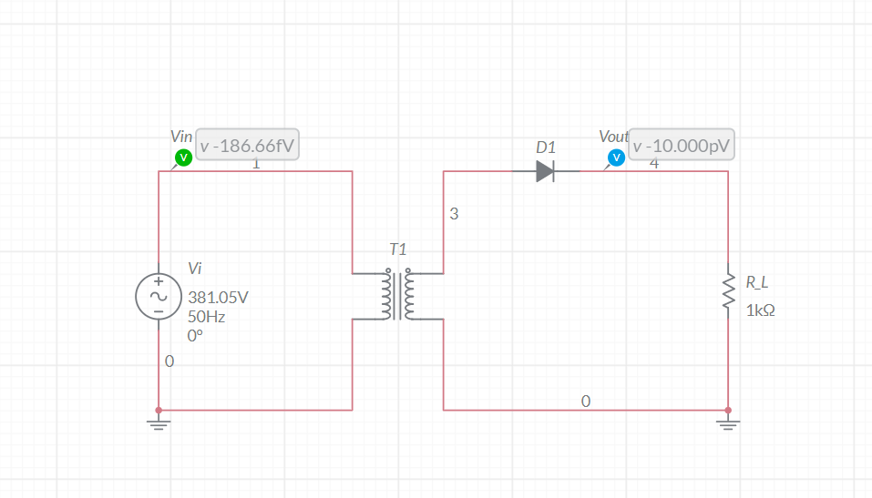

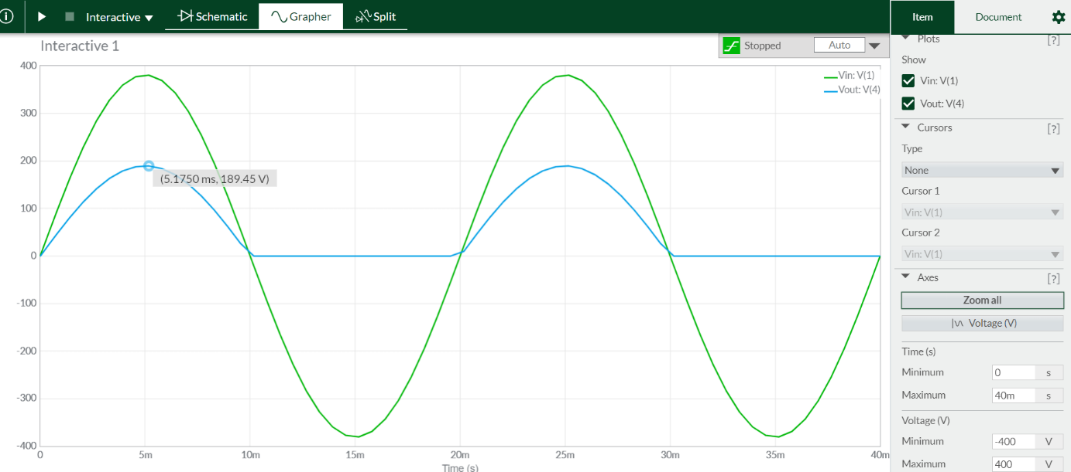

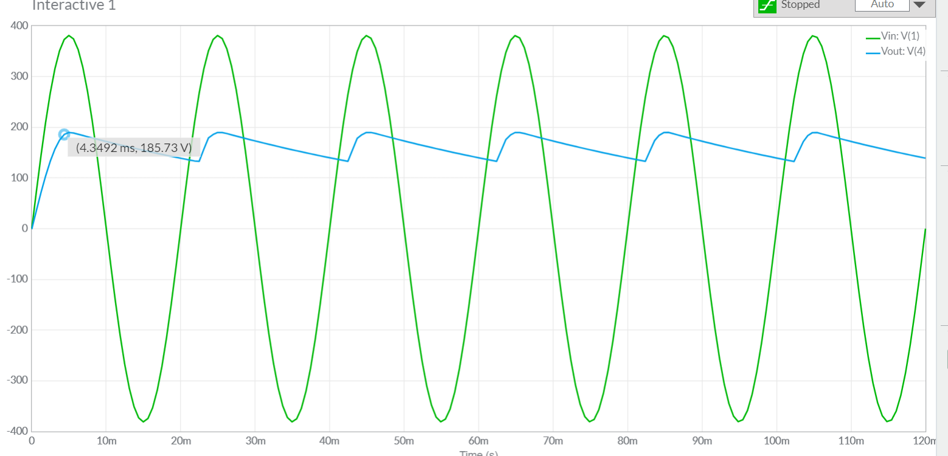

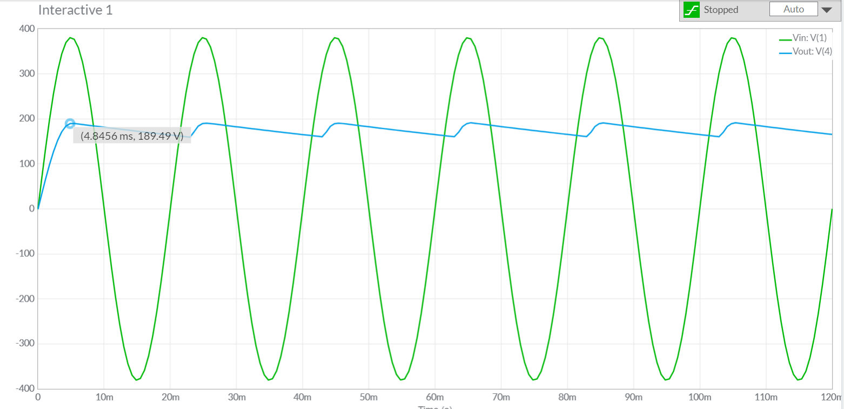

**Figure:2**

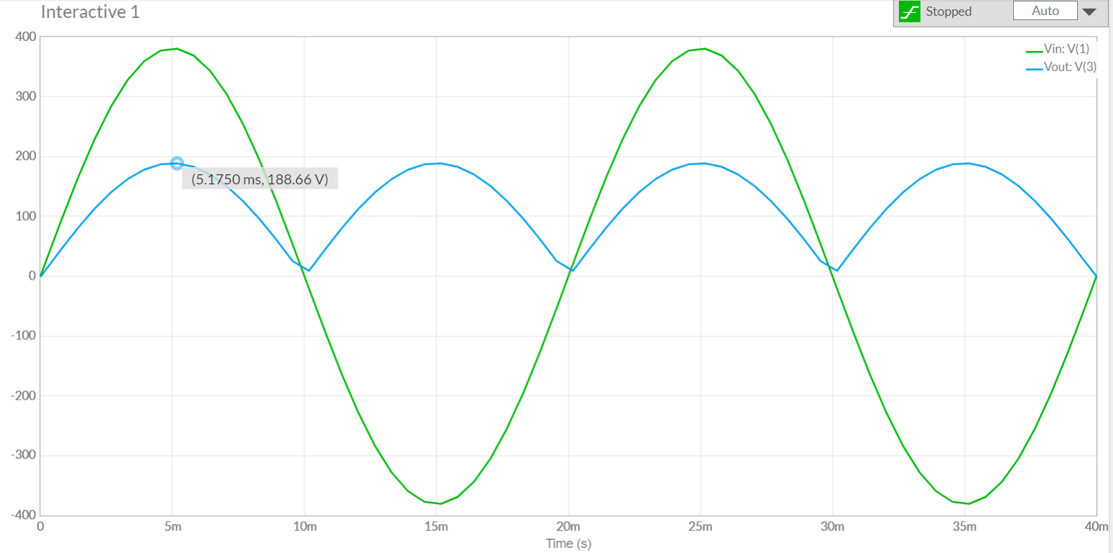

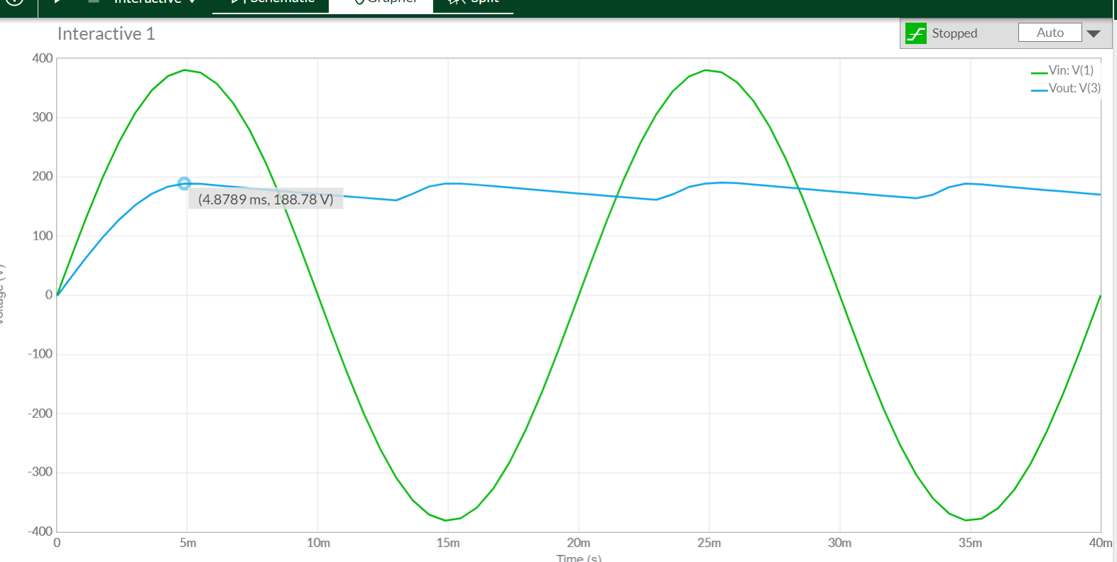

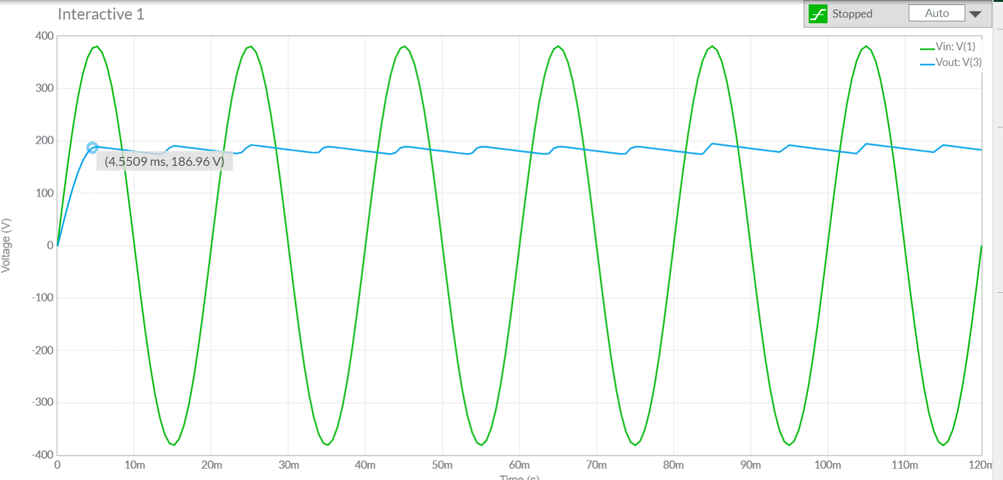

**Figure:3**

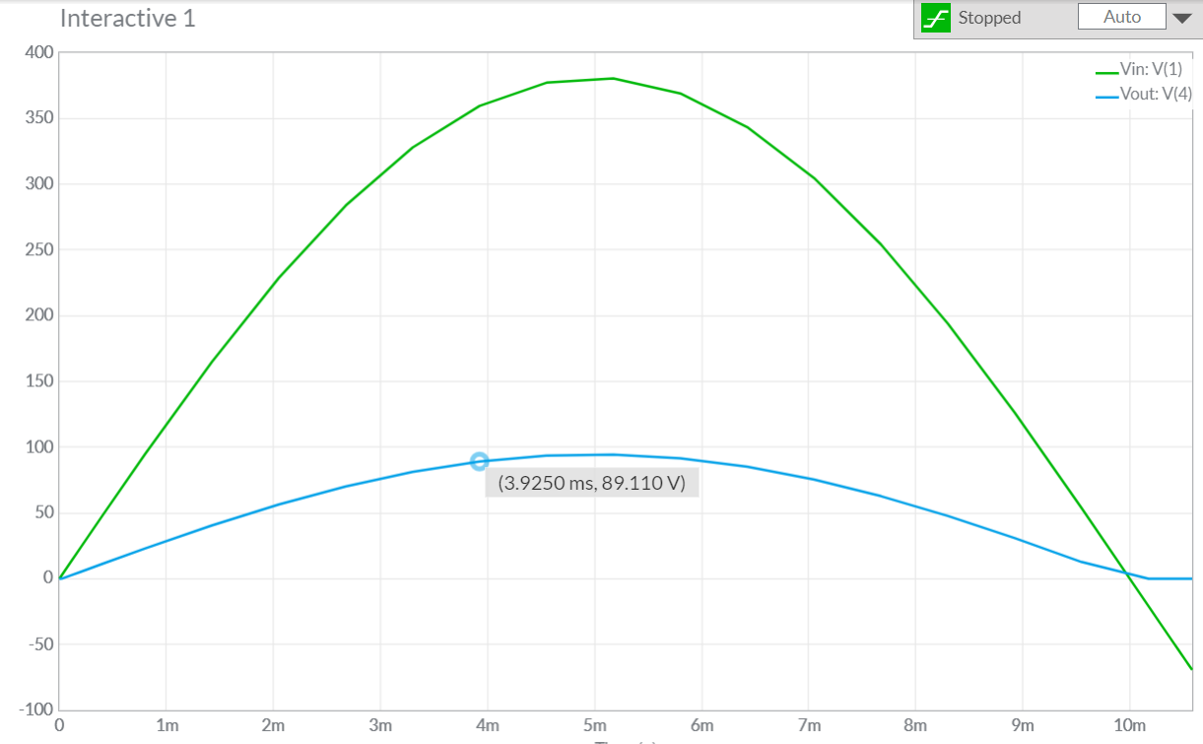

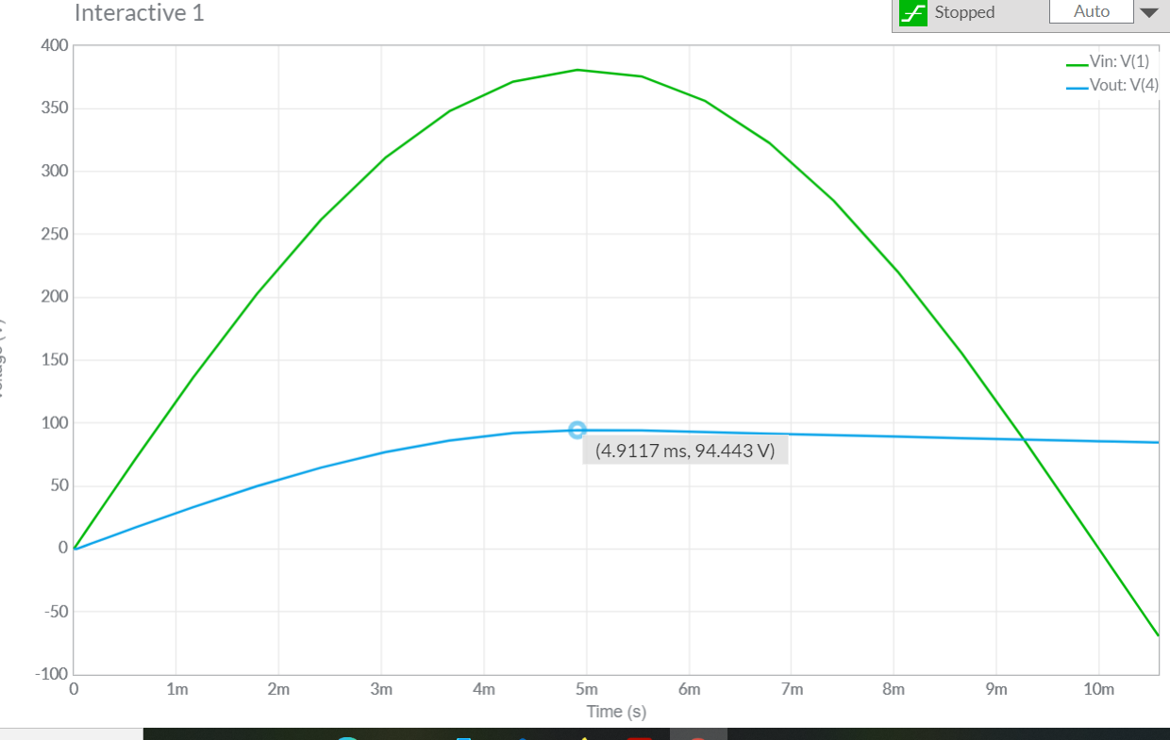

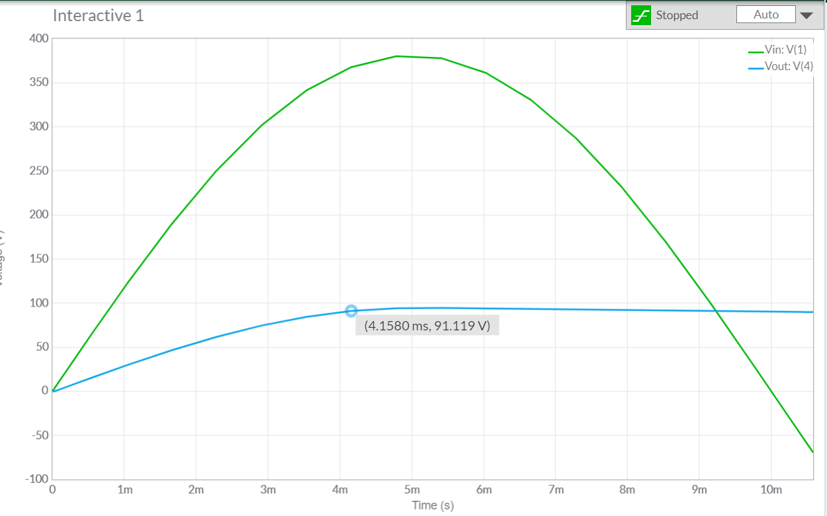

**Experimental Data:**

**Table 1: Data Table for circuit of Figure – 1**

|  |  |  |
| --- | --- | --- |
|  | Vo (Oscilloscope) | Vo ( Multimeter) |
| No Capacitance | 189.45V |  |
| 47μF | 185.73V |  |
| 100 μF | 189.49V |  |

**Table 2: Data Table for circuit of Figure – 2**

|  |  |  |
| --- | --- | --- |
|  | Vo (Oscilloscope) | Vo ( Multimeter) |
| No Capacitance | 188.66V |  |
| 47μF | 188.78V |  |
| 100 μF | 186.96V |  |

**Table 3: Data Table for circuit of Figure – 3**

|  |  |  |
| --- | --- | --- |
|  | Vo (Oscilloscope) | Vo ( Multimeter) |
| No Capacitance | 89.11V |  |
| 47μF | 94.44V |  |
| 100 μF | 91.12V |  |

**(5) Report Question:**

i)All shapes draw done.

ii) A capacitor-input filter is a filter circuit in which the first element is a capacitor connected in parallel with the output of the rectifier in a linear power supply. The capacitor increases the DC voltage and decreases the ripple voltage components of the output.

iii) 186.96V and 89.11V

iv) From oscilloscope we can see that the circuit 2 with capacitance of 100μF is best among all of the simulations on the way of smoother voltage and efficient outcome.

v)All experiment discussion done.

**(6) Discussion:**

From this experiment, we became familiar with half wave rectifier and full wave bridge rectifier and we were able to build the rectifier circuit. For building the circuit, we choose diodes that can safely withstand the current the circuit will have to provide and also the reverse bias voltage that will be applied to it. Diodes are rated for maximum average forward current, which, since the diode conducts only half the time (positive-going half-cycle only), is roughly ½(Vav/RL), where Vav is the average voltage and RL is the load resistance. The peak inverse voltage (PIV), or maximum repetitive voltage (VRRM) is the maximum reverse bias that the diode can withstand. For the unfiltered rectifier, this is just peak voltage. The half wave rectifier is used most often in low-power applications because of their major disadvantages being. The output amplitude is less than the input amplitude, there is no output during the negative cycle so half the power is wasted and the output is pulsed DC resulting in excessive ripple. By performing the experiment, we became familiar with all this.

**(7) References:**

1. Adel S. Sedra, Kennth C. Smith, “Microelectronic Circuits”, Saunders College Publishing, 3rd ed., ISBN: 0-03-051648-X, 1991

2. David J. Comer, Donald T. Comer, Fundamentals of Electronic Circuit Design, John Wiley & Sons Canada, Ltd.; ISBN: 0471410160, 2002.

3. American International University–Bangladesh (AIUB) Electronic Devices Lab Manual.